**Extra Practices 4_and_5**

***Theoretical Questions***

1. If x=3, y=0, and z=-4, what is the value of the following expressions?
   1. X&&y|| z b. x||y&& z c. (x&&y)|| z
2. If originally x=4, y=0, z=2, what is the value of x, y, and z after executing the following code?

*If (x!=0)  
 y=3;  
 else  
 z=2;*

1. **\*\*\*Challenge question:** If originally x=4, y=0, z=2, what is value of x, y, and z after executing the following code?

*If (z==0|| x && !y)   
 if (!z)  
 y=1;  
 else   
 X=2;*

1. What value is assigned to fee by *if* statement when *speed* is 75?

*If (speed>35)  
 fee=20.0;  
else if (speed> 50)  
 fee=40.00;  
else if (speed>75)  
 fee=60.00;*

1. Answer Exercise 1 for the *if* statement that follows*.* Which *if* statement seems reasonable?

*If (speed>75)  
 fee=60.0;  
else if (speed> 50)  
 fee=40.00;  
else if (speed>35)  
 fee=20.00;*

1. What output lines(s) are displayed by the statements that follow when grade is ‘I’? When grade is ‘B’? When grade is ‘b’?

***Switch (grade){***

***Case ‘A’:***

***points=4;  
 break;  
Case ‘B’:***

***points=3;  
 break;  
Case ‘C’:***

***points=2;  
 break;  
Case ‘D’:***

***points=1;  
 break;  
Case’E’:  
Case ‘I’:  
Case ‘W’:  
 points=0;  
}***

***if (points>0)  
 printf (“Passed, points earned =%d\n”, points);***

***else***

***printf (“Failed, no points earned \n”);***

***\*\*Questions marked challenge are those which need an extra bit of creativity or mathematical background: Ask if you would like to learn how to solve them***

***Programming Questions***

1. Write a program that calculates the change due a customer by denomination that is, how many pennies, nickels, dimes, etc. are needed in change. The input is to be the purchase price and the size of the bill tendered by the customer ($100, $50, $20, $10, $5, $1).
2. Write a program that calculates the user’s body mass index (BMI) and categorizes it as underweight, overweight, normal, overweight, or obese, based on the following table from the United States Center for Disease Control:  
   **BMI Weight Status  
   _______________________________**below 18.5 Underweight  
   18.5-24.9 Normal  
   25.0-29.9 Overweight  
   30.0 and above Obese

1. Write a program that takes the *x-y* coordinates of as point in Cartesian plane and prints a message telling either an axis on which the point lies or the quadrant in which it is found.

Y

QII QI  
  
  
QIII QIV

X

Sample lines of output:  
 *(-1.0, 2.5) is in quadrant III  
 (0.0, 4.8) is on the y axis*

1. **\*\*\*\*\*Challenge Question:** Write a program that prompts the user to enter a number, if the number is zero or positive then print, “your number is greater than or equal to zero” otherwise print “your number is less than zero”. Also, check if the number is a whole number and then print “your number is integer” otherwise print “your number is floating point”. ***Hint: the floor () and ceil() of an integer value are equal.***
2. Use switch statements to write a program which shows the following menu to the user:
   1. Rectangle
   2. Triangle
   3. Parallelogram

The user will be prompted to select an option and also will enter the required information for the   
 selected shape; the program will calculate the area of that shape and display it on the output.

1. Re-write the second program but change the menu options to be numeric values.
2. Write a program that displays the following menu to the user:
   1. **Carbon monoxide**
   2. **Hydrocarbons**
   3. **Nitrogen oxide**
   4. **Non-methane hydrocarbons  
        
      Enter pollutant number>>b  
      Enter number of grams emitted per mile>>0.35  
      Enter odometer reading>>040112  
      Emissions exceed permitted level of 0.31 grams/mile  
      ***********Find the decision table for this question on the next page.**

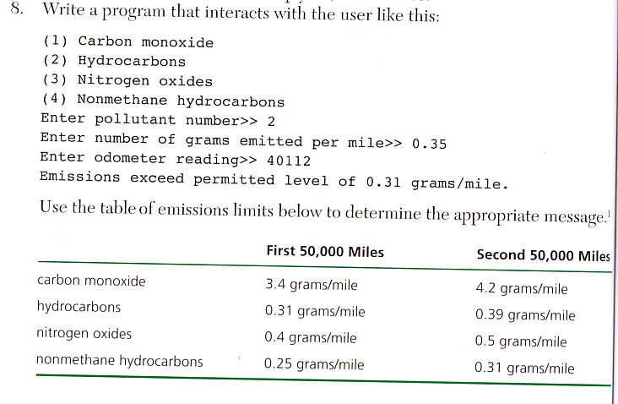**Use the emission table here below to determine the appropriate message.**